Homework 1:
Simplify the following expression using boolean algebra:

a. AB + A(CD + CD’)

b. (BC’ + A’D)(AB’ + CD’)

Given the boolean function F = xy’z + x’y’z + xyz

a. List the truth table of the function.

b. Draw the logic diagram using the original Boolean expression.

c. Simplify the algebraic expression using Boolean algebra.

d. List the truth table of the function form the simplified expression and show that it is the same as the truth table in part a.

e. Draw the logic diagram from the simplified expression and compare the total number of gates with the diagram of part b.

Simplify the following Boolean functions using four-variable maps:

a. F(A, B, C, D) =Σ (4,6,7,15)
b. F(A, B, C, D) = Σ (3,7,11,13,14,15)
c. F(A, B, C, D) = Σ (0,1,2,4,5,7,11,15)
d. F(A, B, C, D) = Σ (0,2,4,5,6,7,8,10,13,15)

Homework 2:

Given the following boolean expression F = x’y + xyz’:

a. Derive an algebraic expression for the complement F’.
b. Show that F * F’ = 0
c. Show that F + F’ = 1

Simplify the following expression in sum of products form and product of sums form.

a. x’z’ + y’z’ + yz’ + xy
b. AC’ + B’D + A’CD + ABCD

Simplify the Boolean function F together with the dont-care conditions d in sum of products for mand product of sums form.

F(w,x,y,z) = Σ(0,1,2,3,7,8,10)
d(w,x,y,z) = Σ(5,6,11,15)

Homework 3:

Design a combinatorial circuit with three inputs x,y,z and three outputs A,B,C. When the binary input is 0,1,2, or 3, the binary output is one greater than the input. When the binary input is 4,5,6,or 7, the binary output is one less than the input.

D Latch problem:

Homework 4:

Construct a 5 to 32 line decoder with four 3 to 8 line decoders with enable and one 2 to 4 line decoder. Use block diagrams similar to figure 2-3.

Construct a 16 to 1 line multiplexer with two 8 to 1 line multiplexers and one 2 to 1 line multiplexer. Use block diagrams for the three multiplexers.

Draw the block diagram of a dual 4 to 1 line multiplexers and explain its operation by means of a function table.

Homework 5:

Include a synchronous clear capability to the register with parallel load of figure 2-7.

Perform the subtraction with the following unsigned binary numbers by taking the 2’s complement of the subtrahend.
a. 11010 – 10000
b. 11010 – 1101
c. 100 – 110000
d. 1010100 – 1010100

Show how you would change Figure 2.11 to make Load the highest precedence signal, followed by Increment, followed by Clear.

Homework 6:

The outputs of four registers, R0, R1, R2, and R3, are connected through 4 to 1 line multiplexers to the inputs of a fifth register, R5. Each register is eight bits long. The required transfers are dictated by four timings variables T0 through T3 as follows.

T0: R5 ← R0
T1: R5 ← R1
T2: R5 ← R2
T3: R5 ← R3

What has to be done to the bus system of Fig. 4-3 to be able to transfer information from any register to any other register? Specifically, show the connections that must be included to provide a path from the outputs of register C to the inputs of register A.

A digital computer has a common bus system for 16 registers of 32 bits each.
The bus is constructed with multiplexers.
a. How many selection inputs are there in each multiplexer?
b. What size of multiplexers are needed?
c. How many multiplexers are there in the bus?

Using a 4-bit counter with parallel load as in Fig. 2-11 and a 4-bit adder as in Fig. 4-6, draw a block diagram that shows how to implement the following statements:

x: R1 ← R1 + R2 Add R2 to R1
x’y: R1 ← R1+1 Increment R1

where R1 is a counter with parallel load and R2 is a 4-bit register.

Homework 7:

The following control inputs are active in the bus system show in Fig. 5-4. For each case, specify the register transfer that will be executed during the next clock transition.

S2 S1 S0 LD of register Memory Adder
a. 1 1 1 IR READ
b. 1 1 0 PC
c. 1 0 0 DR WRITE
d. 0 0 0 AC Add

Explain why each of the following microoperations cannot be executed during a single clock pulse in the system shown in Fig. 5-4. Specify a sequence of microoperatiosn that will perform the operation.
a. IR ← M[PC]
b. AC ←AC + TR
c. DR ←DR+AC (AC does not change)

Consider the instruction formats of the basic computer shown in Fig. 5-5 and the list of instructions given in Table 5-2. For each of the following 16 bit instructions, give the equivalent four digit hexadecimal code and explain in your own words what it is that the instruction is going to perform.
a. 0001 0000 0010 0100
b. 1011 0001 0010 0100
c. 0111 0000 0010 0000

Homework 8:

An instruction at address 021 in the basic computer has I = 0, an operation code of the AND instruction, and an address part equal to 083 (all numbers are in hexadecimal). The memory word at address 083 contains the operand B8F2 and the content of AC is A937. Go over the instruction cycle and determine the contents of the following registers at the end of the execute phase: PC, AR, DR, AC, and IR. Repeat the problem six more times starting with the operation code of another memory reference instruction.

The content of PC in the basic computer is 3AF (all numbers are in hexadecimal). The content of AC is 7EC3. The content of memory at address 3AF is 932E. The content of memory at address 32E is 09AC. The content of memory at address 9AC is 8B9F.
a. What is the instruction that will be fetched and executed next?
b. Show the binary operation that will be performed in the AC when the instruction is executed.
c. Give the contents of registers PC, AR, DR, AC, and IR in hexadecimal and the values of E, I, and the sequence counter SC in binary at the end of the instruction cycle.

Assume that the first six memory-reference instructions in the basic computer listed in table 5-4 are to tbe changed to the instructions specified in the following table. EA is the effective address that resides in AR during the time T4. Assume that the adder and logic circuit in Fig. 5-4 can perform the exclusive-OR operation AC ← AC XOR DR. Assume further that the adder and logic circuit cannot perform subtraction directly. The subtraction must be done using the 2’s complement of the subtrahend by complementing and incrementing AC. Give the sequence of r3egister transfer statements needed to execute each of the listed instructions starting from timing T4. Note that the value in AC should not change unless the instruction specifies a change in its content. You can use TR to store the content of AC temporary of you can exchange DR and AC.

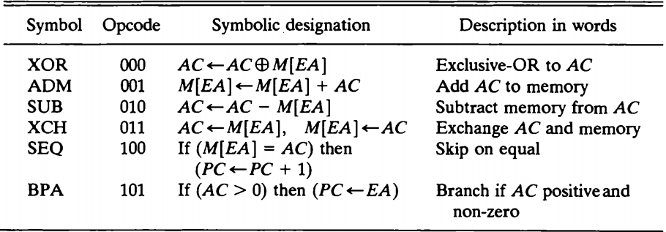

Homework 9:
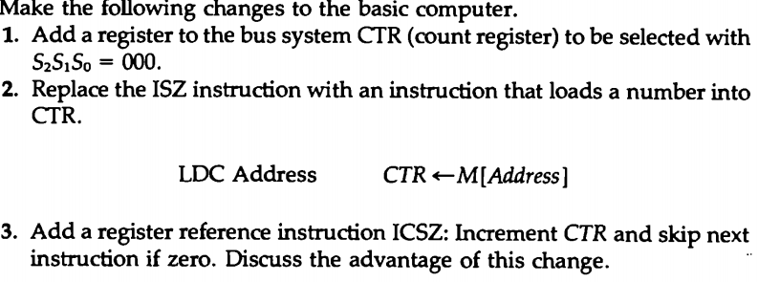
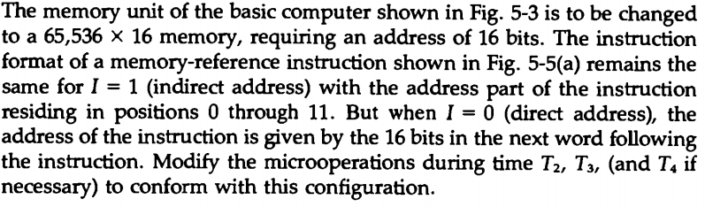
Derive the control gates associated with the program counter PC in the basic computer.

Homework 10:
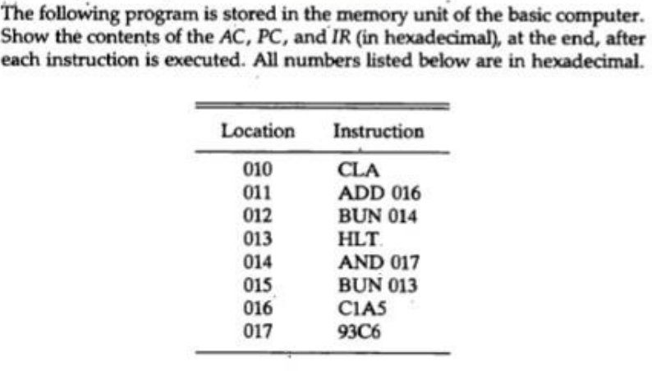

Can the letter I be used as a symbolic address in the assembly language program defined for the basic computer? Justify the answer.

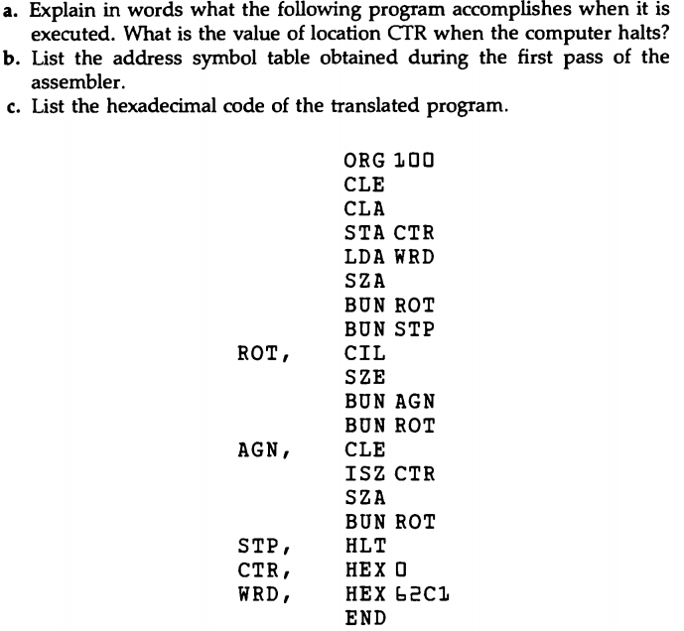

Homework 11:
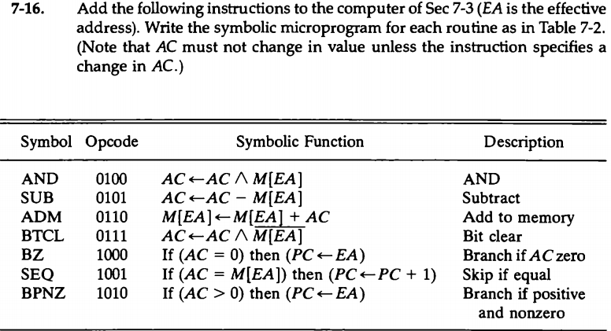

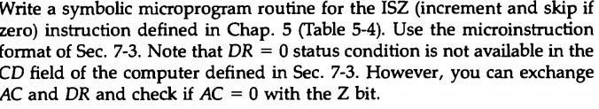

Summarize one of the topics we discussed (probably what makes a PC a PC, vs...something else).

